PRESS RELEASE

**Introducing Kverneland Sync**

The Next Step in Implement Connectivity

September 2024 Nieuw Vennep, Netherlands

**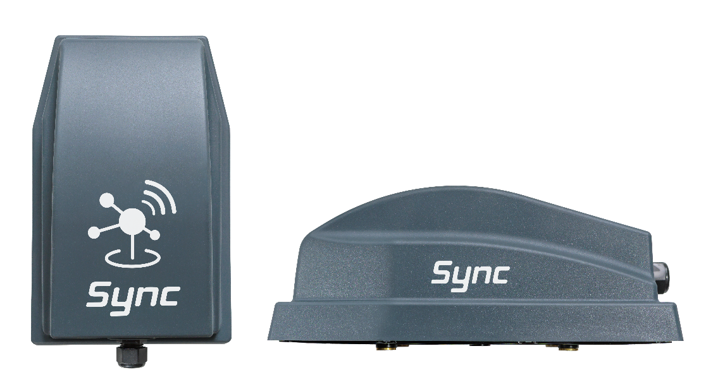**

*The new Kverneland implement gateway*

**Kverneland is proud to announce the launch of Kverneland Sync, a new implement gateway designed to improve data exchange in farming through reliable mobile network connectivity. Built on the foundation of productivity, quality, and growth, Kverneland Sync presents the next step forward in farm management, focusing on connectivity and operational efficiency.**

**Enabling Connectivity and Convenience**

Kverneland Sync represents modern agriculture. Its "Always Connected" feature ensures your implement stays seamlessly linked to Kverneland online services, regardless of an ISOBUS terminal. This eliminates manual syncing, enhances efficiency and allows seamless data transfer to IsoMatch FarmCentre and Kverneland ServiceCentre.

**Task Management and Remote Service**

With Kverneland Sync, seamless data transfer ensures that all information is readily available in IsoMatch FarmCentre, our integrated farm management platform. It simplifies tasks by enabling real-time tracking of operational behaviour and diagnostic trouble codes (DTCs), while also providing detailed reporting and secure data storage. Users also benefit from remote support capabilities through Kverneland ServiceCentre, enabling technicians to analyse data and resolve issues promptly, even from a distance.

**New Features and Enhanced Safety**

Kverneland Sync goes beyond connectivity, offering a host of innovative features aimed at optimising farm operations. From the synchronisation with Kverneland implement apps to precise tracking and geofencing capabilities, farmers can experience the automated operations documentation, enhanced safety measures and craft precise task planning like never before.

**Experience Connected Farming with Kverneland Sync**

Karl Engelbrecht, Director of Digital Customer Solutions at Kverneland Group, stated that Kverneland Sync represents a significant advancement in agricultural connectivity and productivity. "Through seamless integration of implements with digital tools, we empower farmers to maximize profitability, growth, and success through real-time data analysis and performance measurement," he added.

*Number of characters including spaces: 2322*

\*\*\*

**Kverneland is a brand of Kverneland Group**

Kverneland Group is a leading international company developing, producing and distributing agricultural machinery and services. Strong focus on innovation allows us to provide a unique and broad product range with high quality. Kverneland Group offers an extensive package aimed at the professional farming community, covering the areas of soil preparation, seeding, forage and bale equipment, spreading, spraying and electronic solutions for agricultural tractors and machinery. For more information on Kverneland Group visit [www.kvernelandgroup.com](http://www.kvernelandgroup.com)

- - END - -

Download high resolution images

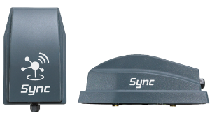

[Kverneland Sync Studio Picture](https://download.kvernelandgroup.com/media/files-pdf-pp-zip/sync-marketing-materials/studio-photos/press-release_hero-image)

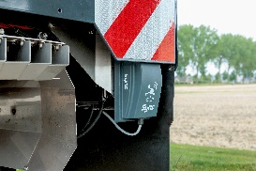

[Kverneland Sync on an ISOBUS Spreader](https://download.kvernelandgroup.com/media/files-pdf-pp-zip/sync-marketing-materials/studio-photos/sync_spreader)

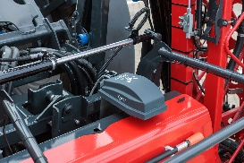

[Kverneland Sync on iXtrack T4 Sprayer](https://download.kvernelandgroup.com/media/files-pdf-pp-zip/sync-marketing-materials/studio-photos/kverneland-sync_sprayer)

**For Details, Contact:**

Dr. Max Bouten

Product Director

Kverneland Group Mechatronics B.V., Netherlands

E-Mail: [Max.Bouten@kvernelandgroup.com](mailto:Max.Bouten@kvernelandgroup.com)

|  |  |  |  |  |  |  |  |  |  |  |  |  |  |  |  |  |
| --- | --- | --- | --- | --- | --- | --- | --- | --- | --- | --- | --- | --- | --- | --- | --- | --- |
| **Kverneland on Social Media** | | | | | | | | | | | | |  | | | |
|  | |  | | |  |  | | |  | |  | |  | | |  |
| 2020-07-30_SocialMediaIcons_RGB_Facebook | | [Kverneland](http://www.facebook.com/KvernelandGroup) | |  | [@KvernelandGroup](http://twitter.com/kvernelandgroup) | | | 2020-07-30_SocialMediaIcons_RGB_YouTube | [kvernelandgrp](http://www.youtube.com/kvernelandgrp) | | 2020-07-30_SocialMediaIcons_RGB_Instagram | | [Kverneland](https://www.instagram.com/kverneland_ien/) | | 2020-07-30_SocialMediaIcons_RGB_LinkedIn | [Kverneland Group](https://www.linkedin.com/company/kverneland-group/) | | |