PRESS RELEASE

**Introducing Vicon Sync: The Next Step in Implement Connectivity**

15.09.2024, Nieuw Vennep, Netherlands

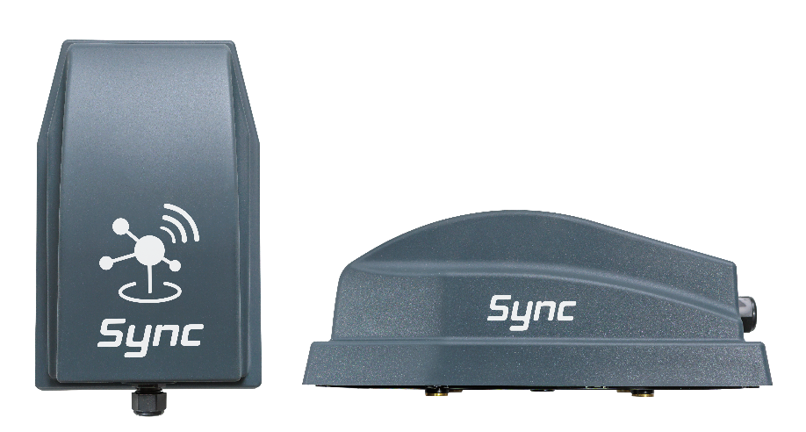

*The new Vicon implement gateway*

**Vicon is proud to announce the launch of Vicon Sync, a new implement gateway designed to improve data exchange in farming through reliable mobile network connectivity. Vicon Sync offers farmers newfound freedom and growth opportunities in their operations.**

**Enabling Connectivity and Convenience**

Vicon Sync is more than just an implement gateway – it's the next step for connected farming. The "Always Connected" feature ensures your Vicon ISOBUS implement stays seamlessly linked to Vicon online services, regardless of a terminal. This eliminates manual syncing, enhances efficiency and allows seamless data transfer to IsoMatch FarmCentre and Vicon ServiceCentre,

**Task Management and Remote Service**

With Vicon Sync, seamless data transfer ensures that all information is readily available in IsoMatch FarmCentre, our integrated farm management platform. It simplifies tasks by enabling real-time tracking of operational behaviour and diagnostic trouble codes (DTCs), while also providing detailed reporting and secure data storage. Users also benefit from remote support capabilities through Vicon ServiceCentre, enabling technicians to analyse data and resolve issues promptly, even from a distance.

**Optimisation and Safety**

Vicon Sync ensures users remain in control of their connected implements at all times. From the Vicon implement apps synchronisation to precise tracking and geofencing, farmers can now enjoy automated operations documentation, enhanced safety and streamlined task planning. With real-time status updates, location tracking and instant notifications for geofence breaches, Vicon Sync ensures users can mitigate risks and safeguard their assets effectively.

**Experience the Connected Farming with Vicon Sync**

"With Vicon Sync, we're welcoming a new era of connectivity and productivity" said Karl Engelbrecht, Director of Digital Customer Solutions at Kverneland Group. "By seamlessly integrating our implements with advanced digital tools and services, we're empowering farmers to achieve optimum performance, reduce costs, and make informed decisions based on real-time data."

Number of characters including spaces: *2225*

\*\*\*

**Vicon is a brand of Kverneland Group**

Kverneland Group is a leading international company developing, producing and distributing agricultural implements, electronic solutions and digital services. Productivity, efficiency, and sustainability are three important principles in today's agriculture, driving us every day to continuously develop our Agricultural Implement Technology. Kverneland Group offers an innovative range of soil and seeding equipment, forage and bale equipment, spreading, spraying, electronic solutions and digital farm services for agricultural tractors and implements. For more information on Kverneland Group, visit [www.kvernelandgroup.com](http://www.kvernelandgroup.com)

- - END - -

Download high resolution images

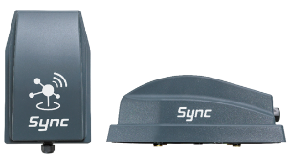

[Vicon Sync Studio Picture](https://download.kvernelandgroup.com/media/files-pdf-pp-zip/sync-marketing-materials/studio-photos/press-release_hero-image)

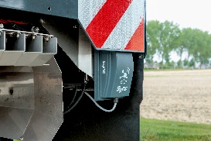

[Vicon Sync on an ISOBUS Spreader](https://download.kvernelandgroup.com/media/files-pdf-pp-zip/sync-marketing-materials/studio-photos/sync_spreader)

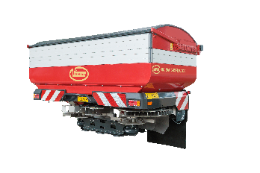

[Vicon Sync on RO-EDW GEOSPREAD iDC](https://download.kvernelandgroup.com/media/files-pdf-pp-zip/sync-marketing-materials/studio-photos/vicon-sync-on-ro-edw-geospread-idc)

**For Details, Contact:**

Dr. Max Bouten

Product Director

Kverneland Group Mechatronics B.V.

Mobile: +31 682318044

E-Mail: [Max.Bouten@kvernelandgroup.com](mailto:Max.Bouten@kvernelandgroup.com)

|  |  |  |  |  |  |  |  |  |  |
| --- | --- | --- | --- | --- | --- | --- | --- | --- | --- |
| **Vicon on Social Media** | | | | | | | | | |
| 2020-07-30_SocialMediaIcons_RGB_Facebook | [Vicon](https://www.facebook.com/www.vicon.eu/) |  | [@KvernelandGroup](http://twitter.com/kvernelandgroup) | 2020-07-30_SocialMediaIcons_RGB_YouTube | [kvernelandgrp](http://www.youtube.com/kvernelandgrp) | 2020-07-30_SocialMediaIcons_RGB_Instagram | [Vicon](https://www.instagram.com/vicon_ien/) | 2020-07-30_SocialMediaIcons_RGB_LinkedIn | [Kverneland Group](https://www.linkedin.com/company/kverneland-group/) | |